Climate Policy

Sports and Leisure Group NV
Version: 03
Date: 6/09/2025

CONTENT
__

Introduction
Why and what is needed to combat climate change?
__

Our sustainability activities
What are we doing to contribute?
__

Our GHG reduction targets
What are we
committing to?
__

Our climate ambition
What GHG reduction measures will we implement?

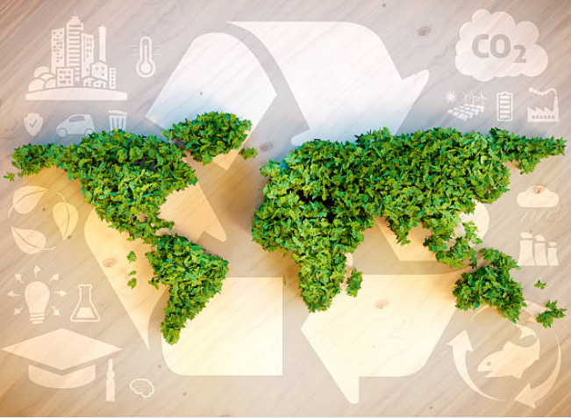
Introduction

Why is Corporate Social Responsibility (CSR) and innovation important in our sector?
It is well known that industry in general has a major impact on the environment. On the other hand, it has the greatest capacity to minimise its negative impact. Within the artificial turf industry, companies are mainly concerned with the perception of the synthetic turf product, as it is made of plastic. Corporate Social Responsibility (CSR) and sustainable innovation therefore plays an important role in the synthetic grass industry. A good CSR strategy can guide companies in innovating their operations and products to always make the most sustainable choices.
By committing to the climate neutral certification, we can prove our dedication to reduce the footprint of our organisation as well as selected products. We see that the future of synthetic turf is already very promising. The industry's commitment to sustainability and innovation focused on the EU Green Deal and the upcoming ECHA microplastic ban, will ultimately lead to better and more sustainable sports and leisure facilities for the environment, players, and clubs.

Our sustainability activities
Sports & Leisure Group aspires to maintain and further expand its leading position in the artificial turf industry. Our goal is to set the course for the sustainable development of synthetic turf systems. We integrate human rights, consumer interests and social, ethical and environmental issues into our operations and core strategy.
Since 2021, we have received annually the gold medal from EcoVadis. This is an assessment platform that evaluates companies based on their sustainability management system. The result placed the sustainability efforts of Sports & Leisure Group in the top 3% of all businesses in the sector. For this reason, they awarded us with a gold medal.
We conduct our business in an appropriate and ethical manner. We are committed to the ten principles of the UN Global Compact in the areas of human rights, labour, the environment, and anti-corruption.
In addition, we are committed to ensuring that our employees have a safe and healthy work environment where they can have the opportunity for personal development. This is done through training and learning on the job with a work buddy. We also have a social programme where we (re)integrate people into a job in the textile sector. In The Netherlands, we also work with municipalities to employ local people to generate social return. For our efforts we received PSO certificate for social entrepreneurship in the Netherlands. . We have a phase 2 audit planned for ISO 45001 (occupational health and safety).
Our vision is to develop synthetic turf systems that are fully circular and water efficient. We developed Infinitum, a latex and polyurethane free backing that is fully recyclable in closed loop. At the end of 2024, we also developed a patented Looppile shockpad made of polyolefin, called Domo Pulse. The end goal is to use recycled yarn and carpet to extrude recycled yarn and produce these shockpads.
In addition, all our artificial grass products are at least recyclable. To put this in practice, we are shareholder of the recycling company GBN Artificial Grass Recycling. This is a company based in the Netherlands that recycles old artificial turf systems in a clean, safe, and circular way.
As the ECHA Microplastic ban lies a restriction on complete artificial grass systems, we logically need to apply product innovations. We do this with natural performance infill, non-infill solutions and yarn technology that keeps infill better in place. In this way we manage to be ECHA complaint.
In 2023, we’ve implemented solar panels and green electricity in our production. In 2024, we introduced the heat recuperation system. We use heat from the oven that is dispersed throughout the factory.
We use post-consumer recycled material in our products certified according ISCC Plus. For carbon reduction we’ve also started Climate Neutral certification in 2023 and achieved CO2 Performance Ladder 5 for the Netherlands in 2025.

Our GHG reduction targets
Organisation (including scope 1,2, business travel and employee commuting)
40 % reduction by 2030
Net-zero by 2050
Product
25 % reduction by 2030

Our climate ambition (see reduction plan)
To achieve above GHG reduction targets, we want to implement the following reduction measures:
(extract from Reduction Plan, vs X, date X)

Description of reduction measure (Organization) | Total envisioned CO2 reduction (T CO2e/year) | Envisioned yr of implementation | Status (planned or committed)
Green electricity contract | 539 | 2024 | Implemented
Installation of solar panels | 0 | 2023 | Implemented
Bike policy | 25 | 2024 | Implemented
Electrification fleet | TBD | 2027 | Implemented
Energy audit measures | 132 | 2026 | Planned, partially implemented
Electric charging points for blue-collar workers | 0 | 2025 | Planned
Heat recovery | 270 | 2025 | Planned, partially implemented
Switch from latex coating to Infinitum coating (less natural gas) | 216 | 2027 (fully) | Committed, already partially implemented
Description of reduction measure (Product) | Total envisioned CO2 reduction (kg CO2e/m2) | Envisioned yr of implementation | Status (planned or committed)
Yarn suppliers switch to green energy in production process | 1.53 | 2026 | Planned
Greening upstream transport | 0.19 | 2026 | Planned
Choose more local suppliers | 0.11 | 2026 | Partially implemented
Switch latex to Infinitum coating | 0.67 | 2027 (fully) | Committed, already partially implemented
Buy more bio-based yarn | 1.65 | 2030 | Committed, already partially implemented
Use more recycled materials | TBD | 2030 | Committed, already partially implemented
Explore fully circular business model | TBD | 2026 | Planned
Greenify downstream transport | 0.4 | 2026 | Planned

NAME SR. MANAGEMENT REPR:____________________________________

SIGNATURE:________________________________________________________

DATE & PLACE SIGNED: ____________________________________________

